Scottish Local Government Elections – Thursday 5 May 2022

Information for Counting Agents

Purpose
The purpose of this guidance is to provide you with a brief outline of the processes to be undertaken in conducting an electronic count and to assist you observe the various stages of the count.

You may wish to refer to the undernoted guidance produced by the Electoral Commission which covers:

- The role of counting agents.
- What to expect at a count.
- How the seats are allocated.
- How doubtful ballot papers are handled and other useful information SLG Part 5 - Your right to attend key electoral events (electoralcommission.org.uk)

An overview of the e-count process
The following diagram shows the key stages in the end-to-end process:
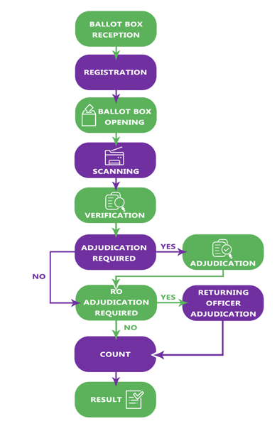
The key features of each stage are:

Ballot Box Reception and Opening | - This stage is a relatively simple process of removing ballot papers from the ballot boxes and putting them into Ballot Paper Trays, marked up with the ballot box detail ready for including in the eCount process.
Registration | - This is the first stage of the eCount process. The Registration/Verification Operator will record the total number of ballot papers expected in the tray from information provided on the Ballot Paper Account.
Scanning | - The contents of each Ballot Paper Tray will be scanned in a number of smaller bundles.
Verification | - The job of the Registration/Verification Operator is to check the number of papers processed by the Scanning Operator agrees with the number entered at the Registration stage. Any variances will be investigated, and the outcome recorded.
1st Level Adjudication  (Standard Adjudication) | - At this stage the 1st Level Adjudicator is only able to process good votes into the eCount system. Any other ballot papers must be deferred to the Returning Officer Adjudication stage for a final decision. No ballot papers are rejected at this stage.
Returning Officer (RO) Adjudication | - The RO will consider all the ballot papers which have been deferred from the first stage adjudication. Any ballot papers which could not be scanned will be entered manually at this stage.  - The RO will run pre-count checks prior to having the system calculate the provisional result which will then be discussed with Candidates and Election Agents.

Progress Screen - The Progress Screen provides an overall summary of progress for each individual Contest. At a glance, we can see the completion status of each stage of the eCounting process.

First Preference Screen - The First Preference Screen displays all candidates and their first preference votes (Note: Only first preference votes). This graph will start to populate as soon as the first Ballot Box has been verified. When all boxes have been verified the provisional quota will be displayed as a vertical line.

To ensure confidence in the result you are urged to identify issues to Count Supervisors as you see them and get them dealt with immediately. Where a Returning Officer has had no indication of perceived problems during the count process, it is unlikely that a request for any form of re-count would be agreed.

Electoral Management Board for Scotland
April 2022

