 | Information for Voters
. Election of 4 councillors to represent
Ward 1- Linn
of Glasgow City Council
1 | After you have been given your ballot paper,  take it to a voting booth. | 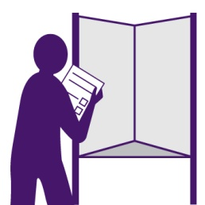
2 | Vote by:  - Putting the number 1 in the voting box next to your first choice.  - Putting the number 2 in the voting box next to your second choice.  - Putting the number 3 in the voting box next to your third choice.  - You can make as many or as few choices as  you wish.  Do not mark the ballot paper in any other way  or your vote may not count.
3 | When you have marked your choices, show the back of the ballot paper to the polling staff, so that they can confirm that the ballot paper has the number and official mark, but do not let anyone see how you have voted.
4 | Put the ballot paper in the ballot box and leave the polling station.
 | If you make a mistake, take the ballot paper to the polling staff and ask for another one.

