Scottish Parliament Election 2026

Information for Returning Officers on new ballot paper overlay and accompanying audio support for blind and partially sighted voters

Electoral Management Board for Scotland Accessibility Subgroup, RNIB Scotland and Sight Scotland and Sight Scotland Veterans

Contents
Introduction 1
The ballot paper overlay 2
Accompanying audio / spoken ballot papers 2
Using the overlay and audio support 3
Training 4
Publicising the new overlay 4
Annex 1 – Suggested script for spoken ballot papers for the Scottish parliament election 5
Annex 2 – Suggested text for webpage or word document for those using text to speech tool or screen reader 8
Annex 3 – Example ballot paper and script 10

Introduction

This guidance provides information to support Returning Officers (ROs) and their teams in the roll out of a new tactile voting aid and accompanying audio support, which are designed to be used without assistance to support blind and partially sighted voters to vote independently and in secret in polling places. The guidance supplements the Electoral Commission’s Guidance for Returning Officers - Assistance with voting for disabled voters | Electoral Commission.

The new ballot paper overlay is an additional option for blind and partially sighted voters and does not replace the existing equipment options, including the older plastic tactile voting device and magnifiers, which should continue to be made available in line with Electoral Commission Guidance (equipment to be provided in polling stations to support disabled electors).

The overlay is consistent with Article 38 (Equipment of polling stations) of Schedule 2 of The Scottish Parliament (Elections etc.) Order 2015.

The guidance incorporates lessons from the testing of the overlay and provides standard scripts for the audio versions of the constituency and regional ballot papers to ensure the experience of voters who seek to use the new aid across Scotland is positive and as consistent as possible.

It has been produced by the Electoral Management Board for Scotland (EMB) in consultation with the EMB’s Accessibility Sub-group, RNIB Scotland and Sight Scotland.

The ballot paper overlay

The overlay is a cardboard template produced to match the size of the ballot paper. It is placed over the ballot paper and has ‘TOP’ written in embossed writing and braille along the top, as well as a cut out top right corner to help with orientation. It has embossed numbers and braille numbers alongside cut out squares which line up with the voting boxes on the ballot paper.

When combined with an audio recording of the ballot paper (see section below), the overlay is intended to provide a complete self-service solution to blind and partially sighted voters to vote independently and in secret.

The new ballot paper overlays will be issued to all Returning Officers by the end of March 2026 so that they can be made available at all polling places for the Scottish Parliament election in May. The printing and shipping are being funded by the EMB.

The full-length overlay has space for 27 candidates, but post production they will be trimmed to whatever lengths are required for the constituency and regional ballot papers so that they match the ballot paper size and format exactly. Every RO will be provided with a supply at a range of lengths for further trimming to the sizes required locally.

Accompanying audio / spoken ballot papers

For the overlay to be used successfully by voters without assistance, it must be accompanied by audio versions of the ballot papers.

The audio version can be hosted in different ways – a phone line, via your usual election helpline or on your website. A website version could be an audio file, YouTube video or a text version that can be read by text to audio apps.

Following testing and advice from RNIB Scotland, it is essential that both the spoken ballot papers and any text versions designed to be read by text to audio apps include the numbers of the cut out boxes that the candidates’ names will be against. Voters should be able to hear which candidate is lined up with which numbered box and navigate to the correct cut out box using the embossed and braille numbers alongside them.

To support consistency across Scotland in relation to the overlay, the annexes to this document provide the following:

- Annex 1 - A suggested script for spoken ballot papers for the Scottish Parliament election. This can also be used where the ballot paper is read out in person
- Annex 2 - Suggested text for a webpage or Word document for those using text to speech tools or screen readers (note – a separate webpage or Word document is recommended so that the box numbers are provided, as set out above)
- Annex 3 - An example ballot paper and script

If there are two candidates with the same name on the ballot paper, it may be necessary to note this in the spoken ballot paper before the list of candidates/parties is read out.

The following principles for the spoken ballot papers draw on tips for audio recordings from the RNIB and the findings from testing:

- Ensure the audio mirrors the ballot paper and the voting box numbers aligned with each candidate are provided
- Use high quality audio without background noise or music
- Ensure a clear voice, neutral tone and correct pronunciation of candidate and constituency names
- Make sure the speed of the audio recording is steady and not too fast, and that there is a gap between candidates to make it easier to differentiate each candidate
- Ensure the option to replay the list of candidates is provided for telephone line options, without the voter having to redial. (Audio recordings provided via YouTube and some other file types will enable the voter to navigate back and forth, which can be helpful)
- Make the spoken ballot papers available in advance of the election as well as in the polling station.

Using the overlay and audio support

If a voter wishes to use the overlays, they should be provided with their constituency and regional ballot papers each placed underneath the correct sized overlay. Polling staff may wish to use paper clips to help to keep the overlays in place. The Presiding Officer should also consider in advance, and make contingency arrangements for, any scenarios where the overlay might be challenging to use (for example, if a long regional ballot paper and overlay may not fit on the writing surface available in the booth).

Voters should have the option to listen to an audio recording of the ballot paper in the polling booth with their mobile phone, so that they know which cut out areas are lined up with which candidates / parties. The audio recording could be provided via a telephone number read out by polling staff, a web address or a QR code on an information sheet or poster.

In areas or buildings where poor reception and/or internet availability may be an issue, the Presiding Officer should consider in advance whether pre downloaded versions of the spoken ballot papers can be made available on a device. Alternatively, a member of polling staff can read out the ballot papers (using the script provided at Sections 2a and 2b of Annex 1).

The ballot paper overlay and supporting audio are designed to enable the voter to vote independently and in secret, but the level of independence will be decided by the voter so if they choose to ask what box number a particular candidate or party is at, they can be provided with that information. Polling staff or a companion assisting a voter are permitted to accompany the voter into the booth to assist them, if requested, as some people are unable to mark their ballot, even with aids.

Training

The EMB is working with Sight Scotland on the production of a training video for polling staff on how best to support visually impaired voters to vote independently and in secret at polling places. This will include how to use the new ballot paper overlay and accompanying audio ballot paper, as well as the existing equipment options (including the older plastic tactile voting device and magnifiers). The video will be available by the end of March 2026.

Publicising the new overlay

It is important that blind and partially sighted people have the information they need in accessible formats in advance of the election, including on what support they can expect and request, the availability of an enhanced option for voting independently and in secret in polling stations, and the names of candidates, and their order on ballot papers.

Information and support for blind and partially sighted voters for the forthcoming election is being developed by the Electoral Commission in collaboration with RNIB Scotland and will be shared with other sight loss charities in Scotland (Guide Dogs Scotland, Sight Scotland and Sight Scotland Veterans, and Visionary). RNIB Scotland is also making plans to distribute information about the availability of the overlay as an improved option to vote independently and in secret in polling stations via its local networks.

ROs should utilise as many channels of communication as they have access to with the visually impaired community to highlight the availability of the overlay and of the audio ballot paper. There will be national publicity, but local engagement will be more effective.

Annex 1 – Suggested script for spoken ballot papers for the Scottish parliament election

Below is a suggested script which could be used for an automated telephone line, including introductory text and the spoken ballot papers. You can adapt this to suit your own telephony systems as required.

You may wish to incorporate other relevant accessibility information. The only sections where it is important to maintain consistency across Scotland in relation to the overlay are those areas in blue text at Section 2a and 2b.

Text highlighted in yellow would vary for each local authority and ballot paper accordingly.
- Greeting
Thank you for calling to hear spoken constituency and regional ballot papers for your area for the Scottish Parliament election taking place on Thursday 7th May 2026.

These spoken ballot papers are available to support you if you wish to use either of the two tactile voting aids which will be available in the polling place. One is a new cardboard ballot paper overlay which fits exactly over the ballot paper. The older plastic tactile voting device is available as an alternative. This must be fitted in place by polling staff.

Please use your keypad to select which ballot paper you would like to hear. If you are not sure which constituency you are in, you can either visit [if accessible - local authority lookup tool / Electoral Commission lookup tool / www.boundaries.scot] and enter your postcode, or please press [*] to speak to someone in the [Elections Office].

- To hear the ballot paper for the [name] constituency, please press 1.
- For the [name] constituency please press 2.
- For the [name] constituency please press 3.
- For the [name] constituency please press 4.
…
- And for the regional ballot paper for the [name] Region, please press [number]

If you would like to speak to someone in the [Elections Office] about the support available to you when voting, requesting a reasonable adjustment at a polling station or anything else, please press [*] or call during office hours on [phone number].
If you would like to hear these options again, please press [#].
2a. Spoken constituency ballot paper
This script is designed for use in an automated recording but should also be followed as closely as possible when a voter calls the office or asks for the ballot paper to be read out in the polling station

You will shortly hear the names of the candidates standing for election to represent the [name] constituency in the Scottish Parliament election on Thursday 7th May 2026.

On the constituency ballot paper, you vote for only one candidate by putting a cross in the box next to your choice. Candidates are listed alphabetically by surname on the ballot paper and will be read out now, surname first, in the order that they appear. We also say which numbered voting box the candidate’s name is next to so that you can find it independently if you are using a tactile voting aid with braille and embossed numbers.

There are [number] candidates listed on this constituency ballot paper.
The candidate next to box one on the ballot paper is [Surname, first name], [party/independent]
At box two is [Surname, first name], [party/independent]
At box three is [Surname, first name], [party/independent]
At box four is [Surname, first name], [party/independent]
… And so on
This is the end of the ballot paper.

If you would like to hear the names of the constituency candidates again, please press [#]

To hear the regional ballot paper for the [name] Region, please press [number]

And if you would like to return to the beginning to select a different constituency ballot paper or hear the information again, please press [*].

2b. Spoken regional ballot paper
This script is designed for use in an automated recording but should also be followed as closely as possible when a voter calls the office or asks for the ballot paper to be read out in the polling station
You will shortly hear the names of the parties [and independent candidates] standing for election to represent the [name] region in the Scottish Parliament election on Thursday 7th May 2026.
On the regional ballot paper, you vote only once by putting a cross in the box next to your choice. The parties [and independent candidates] are listed alphabetically on the ballot paper and will be read out now in the order that they appear. We also say which numbered voting box each party [or independent candidate] is next to so that you can find it independently if you are using a tactile voting aid with braille and embossed numbers.

There are [number] parties [and independent candidates] listed on this ballot paper.
The party [or independent candidate] next to box one on the ballot paper is [Party or Surname, first name]
At box two is [Party or Surname, first name]
At box three is [Party or Surname, first name]
At box four is [Party or Surname, first name]
… And so on
This is the end of the ballot paper.
If you would like to hear the names of the parties and independent candidates standing in the [name] region again please press [#]
If you would like to return to the beginning to select a spoken constituency ballot paper or to hear the information again, please press [1].
If you would like to speak to someone in the [Elections Office] about the support available to you when voting, requesting a reasonable adjustment at a polling station or anything else, please press [*] or call during office hours on [phone number].

Thank you again for calling.

Annex 2 – Suggested text for webpage or word document for those using text to speech tool or screen reader

It is suggested that this text is made available on an elections page on your council website as either its own webpage linked to from main page / accessibility page or as an attached document from main page / accessibility page. This is so that the numbers of the cut out boxes that the candidates names will be against are included in the information provided.

Title: Text versions of ballot papers for use with text to audio apps or screen readers

At the Scottish Parliament election on Thursday 7th May 2026, polling places will have a range of equipment and support options available to support blind and visually impaired voters who wish to vote in person.

Spoken ballot papers are available to support you if you wish to use either of the two tactile voting aids which will be available in the polling place. One is a new cardboard ballot paper overlay which fits exactly over the ballot paper. The older plastic tactile voting device is available as an alternative. This must be fitted in place by polling staff.

This document provides text versions of the constituency and regional ballot papers for your area for use with audio apps or screen readers.

Please select from the list below which ballot paper you would like to hear. If you are not sure which constituency you are in, you can either visit [if accessible - local authority lookup tool / Electoral Commission lookup tool / Boundaries Scotland tool to find your current ward or constituency] and enter your postcode, or call [phone number] to speak to someone in the [Elections Office].

List of ballot papers

Constituency ballot paper for the [name 1] constituency
Constituency ballot paper for the [name 1] constituency
… and so on
Regional ballot paper for the [name] region

[Name 1] Constituency

On the constituency ballot paper you vote for only one candidate by putting a cross in the box next to your choice. Candidates are listed alphabetically by surname on the ballot paper and are listed below, surname first, in the order that they appear. The voting box the candidate is next to is also provided, so that you can find it independently if you are using a tactile voting aid with braille and embossed numbers.

There are [number] candidates listed on the ballot paper for [name] constituency.

The candidate next to box one on the ballot paper is [Surname, first name], [party/independent]
At box two is [Surname, first name], [party/independent]
At box three is [Surname, first name], [party/independent]
At box four is [Surname, first name], [party/independent]

If you would like to go to the text version of the regional ballot paper for the [name] Region, this link will take you to that section: Regional ballot paper for the [name] region.

If you would like to return to the full list of ballot papers available this link will return you to that section: List of ballot papers.

[Name 2] Constituency

As above for as many constituencies as necessary.

[Name 1] Region

On the regional ballot paper you vote only once by putting a cross in the box next to your choice. The parties [and independent candidates] are listed alphabetically on the ballot paper and are listed below in the order that they appear. The voting box the party [or independent candidate] is next to is also provided, so that you can find it independently if you are using a tactile voting aid with braille and embossed numbers.

There are [number] parties [and independent candidates] listed on this ballot paper.

The party [or independent candidate] next to box one on the ballot paper is [Party or Surname, first name]
At box two is [Party or Surname, first name]
At box three is [Party or Surname, first name]
At box four is [Party or Surname, first name]
… And so on

If you would like to return to the full list of ballot papers available this link will return you to that section: List of ballot papers.

If you would like to speak to someone in the [Elections Office] about the support available to vote, about how to request a reasonable adjustment at a polling station or about anything else, please call at any time during office hours on [phone number].

End of document

Annex 3 – Example ballot paper and script

This annex provides an example ballot paper and accompanying spoken ballot paper script below.

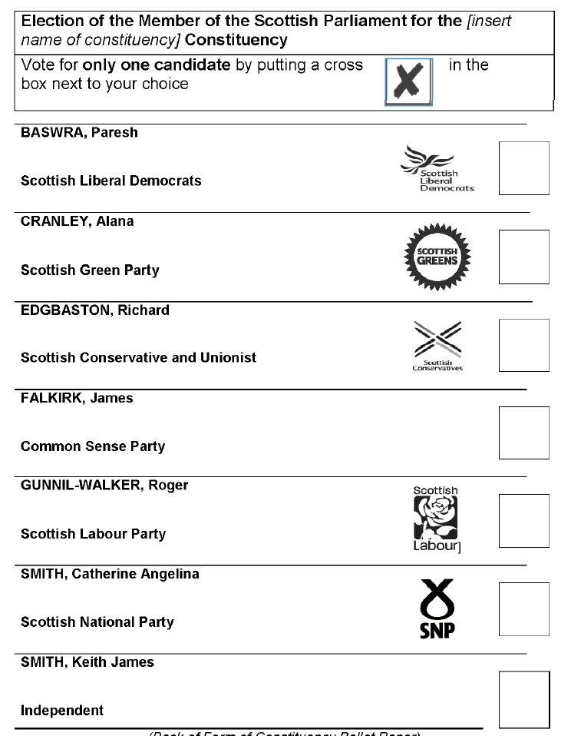

You will shortly hear the names of the candidates standing for election to represent the Angus South constituency in the Scottish Parliament election on Thursday 7th May 2026.

On the constituency ballot paper, you vote for only one candidate by putting a cross in the box next to your choice. Candidates are listed alphabetically by surname on the ballot paper and will be read out now, surname first, in the order that they appear. We also say which numbered voting box the candidate’s name is next to so that you can find it independently if you are using a tactile voting aid with braille and embossed numbers.

There are seven candidates listed on this constituency ballot paper.

The candidate next to box one on the ballot paper is Baswrah, Paresh, Scottish Liberal Democrats
At box two is Cranley, Alana, Scottish Green Party
At box three is Edgbaston, Richard, Scottish Conservative and Unionist
At box four is Falkirk, James, Common Sense Party
At box five is Gunnil-Walker, Roger, Scottish Labour Party
At box six is Smith, Catherine Angelina, Scottish National Party
At box seven is Smith, Keith James, Independent

This is the end of the ballot paper.

