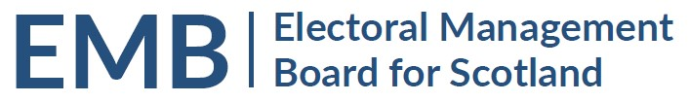Agenda
2pm Wednesday 25 January 2023
Meeting via Teams

MEETING ADMIN
- Apologies
- Previous Meeting 2 December 2022 (circulated)
EMB WORK PROGRAMME
- EMB Future Work Programme
  - Actions following EMB Planning Day – circulated
  - Accessibility Subgroup Terms of Reference – to follow
  - Implementation of UK Elections Act 2022 – oral update
  - Coordination of observation visits to English elections in May 2023 – oral update
  - Proposed RO/ERO Seminar for September 2023 – oral update
  - Response to Scottish Government Consultation on Electoral Reform – oral update/discussion
GENERAL UPDATES
- Fujitsu Review of delivery of by-elections since May 2022 - circulated
- Scottish Government General Update – to follow
- UK Government – Department for Levelling Up, Housing and Communities: Elections and Registration Update
    - UK Funding Working Group – circulated
- Electoral Commission General Update – to follow
- Electoral Registration Update from the Electoral Registration Committee of the SAA update - to follow
- AEA update to follow
- Boundaries Issues
  - 2023 Review of UK Parliamentary Boundaries, Revised Proposals
  - Polling Scheme Reviews
INFORMATION
- EMB Admin
  - Membership – future vacancy to note
  - Annual Report – circulated
- Log of by-elections - circulated
- Any Other Business
DATES OF FUTURE MEETINGS
30 March 2023
Further dates to be agreed

