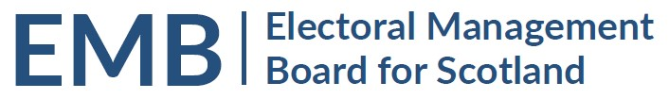Agenda
2pm Thursday 24 March 2022
Meeting via Teams

MEETING ADMIN
- Apologies
- Note of Previous Meeting 24 February 2022 & any Matters Arising - circulated
EMB WORK PROGRAMME
- Preparation for Scottish Local Government Elections 5 May 2022
  - Update on preparations and any issues arising from ROs and EROs
  - eCount for 2022 Scottish Local Government Elections Update - to follow
Note that eCount Project Bulletins are available on the EMB website at https://www.emb.scot/downloads/download/138/ecounting-bulletins-2022
  - Public Health Scotland: impact of Coronavirus on election delivery – oral update
  - 2022 Local Government Candidate Diversity Survey – oral update
GENERAL UPDATES
- Scottish Government General Update
- UK Government – Department for Levelling Up, Housing and Communities: Elections and Registration Update
- Electoral Commission General Update
  - Party Conferences – Fringe events
  - Engagement with ROs
- Electoral Registration Update from the Electoral Registration Committee of the SAA – oral update
- AEA update – oral update
INFORMATION
- EMB Membership
- Any Other Business
DATES OF FUTURE MEETINGS / WORK SCHEDULE
Month | All at 2pm, Teams as default | Notes
April 2022 | 28 April | Final meeting before 5 May polling/ 6 May eCount
June 2022 | 23 June | Opportunity for initial feedback on the conduct of the election

