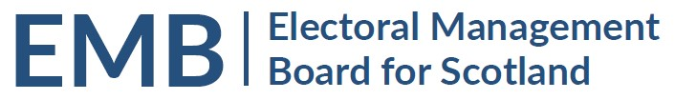Agenda
2pm Thursday 24 February 2022
Meeting via Teams

MEETING ADMIN
- Apologies
- Note of Previous Meeting 10 January 2022 & any Matters Arising - circulated
EMB WORK PROGRAMME
- Preparation for Scottish Local Government Elections 5 May 2022
  - Briefing for Returning Officers and Electoral Registration Offices, 27 January 2022 – Review, update from Electoral Commission / EMB Members
  - eCount for 2022 Scottish Local Government Elections Update - to follow
Note that eCount Project Bulletins are available on the EMB website at https://www.emb.scot/downloads/download/138/ecounting-bulletins-2022
  - Forms Working Group – oral update
  - Public Health Scotland: impact of Coronavirus on election delivery – oral update
  - 2022 Local Government Candidate Diversity Survey – oral update
- Review of Electoral Commission Returning Officer Performance Standards – Mel Davidson to lead discussion
GENERAL UPDATES
- Local Government By-elections – Review since 2007
- Scottish Government General Update – to follow
- UK Government – Department for Levelling Up, Housing and Communities: Elections and Registration Update - March 2022 – circulated
  - UK Elections Bill – Expert Panel Update / Feedback
- Electoral Commission General Update – to follow
  - Party Conferences – Fringe events
  - Engagement with ROs
- Electoral Registration Update from the Electoral Registration Committee of the SAA – oral update
- AEA update – oral update
INFORMATION
- Consultations / Evidence
  - Scottish Local Government Elections (Candidacy Rights of Foreign Nationals) Bill

- Any Other Business
DATES OF FUTURE MEETINGS / WORK SCHEDULE
Month | All at 2pm, Teams as default | Notes
March 2022 | 24 March
April 2022 | 28 April | Final meeting before 5 May polling/ 6 May eCount
June 2022 | 23 June | Opportunity for initial feedback on the conduct of the election

